Mitosis Preview

Read and Listen

Open the Mitosis App on the iPad. Tap on the “Read and Listen” tab found at the top of the screen. You may either read or have the app read the information to you. Answer the following questions:

- What part of the cell is dividing during Mitosis? __________________________________________

- List the 4 phases of the cell cycle and describe what happens in each.

- How many cells are currently dividing in your body? ____________________________________

- What 2 things does mitosis enable your body to do?

- List the 5 phases of Mitosis in order.

- What is the name of the process that occurs at the end of mitosis? What happens
during this phase? __________________________________________________________________________
_________________________________________________________________________________________________

- How many cells are present after mitosis? What do they do once they have been
produced? ____________________________________________________________________________________

_________________________________________________________________________________________________
Eukaryotic Cell Cycle Video

Return to the home screen and Tap on “Videos” under the Library section. Select the video called “The Cell Cycle”. Answer the following questions from the video.

- List the 2 major phases of the eukaryotic cell cycle.

- List the 3 things that a cell does during Interphase.

- List the 3 sub-phases of Interphase. For each stage, explain what occurs.

Sub-phases | Events that occur

- How many chromosomes are in a human cell? ___________________________________________

DNA
DNA can take many forms. When the cell is in interphase, it takes the form of chromatin. Look at a picture of chromatin on the following site:
http://www.cgl.ucsf.edu/chimera/ImageGallery/entries/large_images/chromatin3-large.png
- Describe the appearance of chromatin:_________________________________________
When the cell needs to divide, the DNA must coil up tightly into chromosomes. When DNA has not copied itself, the chromosomes will only have one strand. These strands are called chromatids. After DNA replicates, each strand (chromatid) has a twin that is attached to it. These pairs of twin chromatids are called sister chromatids. Sister chromatids are connected by a centromere. See what chromatids and sister chromatids look like on the following site:
http://library.thinkquest.org/28751/review/division/1.html
- Draw and label a picture of the sister chromatids and the centromere.

Explore

Return to the home screen and Tap on Explore. After reading/listening to the introduction Tap “Start Exploring” at the bottom of the screen. Follow the prompts and move through each of the phases until you have completed the explore section. Fill in the table below as you proceed. (Include information from the description and the animations)

Phases (in order) | Major Events of Phase

Mitosis Videos

Watch the videos “Mitosis” and “Through a Microscope”. After watching the videos identify the stages of mitosis represented in each of the following pictures. (Prometaphase is NOT pictured)
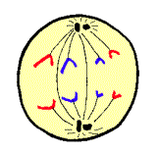 | 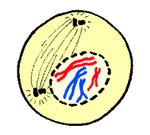 | 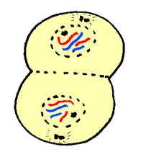 | 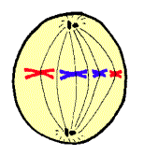

____________ _______________ _______________ _______________

Test Yourself

Return to the home screen and Tap “Test Yourself”. Take the test until you score at least 8 out of 10. Show Mr. Flener once you achieve this score.

