Lab – Use of the Microscope

Introduction:
The human eye cannot distinguish objects smaller than 0.1 mm in size. The microscope is a biological tool that extends vision and allows observation of much smaller objects. The most commonly used compound microscope is monocular (one eyepiece). Light reaches the eye after being passed through the objects to be examined. In this investigation, you will learn how to use and care for a microscope.

Part I - Procedure: Using the Microscope

1. Use the data table at the end of the lab to record your written observations for each item observed under the
microscope.

2. Cut a lowercase letter O from the provided sheet of paper. Place it right side up on a clean slide. With a dropping pipette, place one drop of water on the letter. This type is called a wet mount.

3. Wait until the paper is soaked before adding a cover slip. Hold the cover slip at a 45º angle to the slide and then slowly lower it. Figure "A" below shows these first steps.
Figure "A"
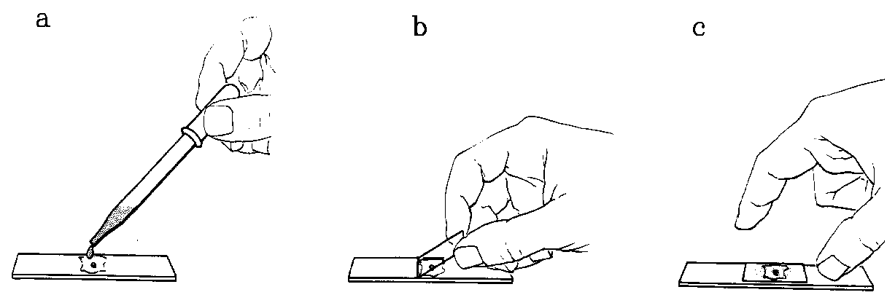

4. Place the slide on the microscope stage and clamp it down. Move the slide so the letter is in the middle of the hole in the stage. Use the coarse-adjustment knob to lower the low-power objective to the lowest position.

5. Look through the eyepiece and use the coarse-adjustment knob to raise the objective slowly, until the letter O is in view. Use the fine-adjustment knob to sharpen the focus. Position the diaphragm for the best light. Compare the way the letter looks through the microscope with the way it looks to the naked eye. Record your observations about the appearance of the letter O in your data table.

6. Locate and Draw the letter O on all 3 powers using the technique described in #4 & #5. Your drawings should go in the circles below and should look identical to what you see in the viewing field for each power.

LOW MEDIUM HIGH

6. To determine how greatly magnified the view is, multiply the number inscribed on the eyepiece by the number on the objective being used. For example, eyepiece (10X) X objective (10X) = total (100X).

a. Calculate the total magnification for low power.

b. Calculate the total magnification for medium power.

c. Calculate the total magnification for high power.

7. Follow the same procedure with the lowercase C. In your data table, describe how the letter C appears when viewed through a microscope. Draw the letter C on all 3 powers in the provided circles below.

LOW MEDIUM HIGH

a. What new information (not revealed by the letter o) is revealed by the c?

8. Make a wet mount of the letter e. Describe how the letter appears when viewed through the microscope in your data table.

a. What new information (not revealed by the letter c) is revealed by the e?

9. Look through the eyepiece at the letter e on low power, as you use your thumbs and forefingers to move the slide slowly away from you.

a. Which way does your view of the letter move?

b. Move the slide to the right. Which way does the image move?

10. Follow the same procedure with the lowercase O. In your data table, describe how the letter e appears when viewed through a microscope. Draw the letter e on all 3 powers in the provided circles below.

LOW MEDIUM HIGH

11. Make a wet mount of two different colored hairs, one light and one dark. Cross one hair over the other. Position the slide so the hairs cross in the center of the field. In your data table, describe how the hairs appear when viewed through a microscope. Draw the hairs on all 3 powers in the provided circles below.

LOW MEDIUM HIGH

a. Can you see both hairs clearly at the same focus level? Explain.

b. How can you use the fine adjustment knob to determine which hair is crossed over the
other?

Answer the Following:

1. Summarize the differences between an image viewed through a microscope and the same image with the naked eye.
2. When viewing an object through the high-powered objective, not all of the object may be in focus. Explain why.
3. What is the relationship between magnification and the diameter of the field of view?

Part II – Procedures: Biological Material
1. Place a small piece of potato in the center of a clean slide. Place the slide on your laboratory table and carefully press the potato with your thumb until some juice is forced out. Distribute the juice evenly over the center of the slide by moving the piece of potato in a circle. Discard the potato. Add a drop of water and a cover slip. Avoid getting air bubbles in the wet mount.

2. Examine the wet mount under the microscope. To increase contrast between the starch grains and water surrounding them, decrease the size of the opening in the substage diaphragm to reduce the amount of light. Move the slide on the stage until you locate a field containing well-separated grains. Center several grains in the field and focus. In your data table, describe how the starch grains appear when viewed through a microscope. Draw the starch grains on all 3 powers in the provided circles below.

LOW MEDIUM HIGH

3. Turn again to low power. Stain the grains by placing a small drop of Lugol’s iodine solution on the slide at one side of the cover slip. Tear off a small piece of paper towel. Place a torn edge in contact with the water at the opposite edge of the cover slip. As water is absorbed by the paper towel at the edge, the Lugol’s iodine solution will be drawn under the cover slip at the opposite edge. Continue until the Lugol’s solution covers half the space under the cover slip. The Lugol’s solution will continue to spread slowly throughout the wet mount.

4. Examine various regions of the wet mount to observe the effects of different concentrations of Lugol’s iodine solution on starch grains. In your data table, describe how the stained starch grains appear when viewed through a microscope. Draw the stained starch grains on all 3 powers in the provided circles below.

LOW MEDIUM HIGH

a. What changes occur in the starch grains exposed to relatively high concentrations of
Lugol’s iodine solution?

b. What differences do you see between these grains and others exposed to lower
concentrations of Lugol’s solution?

5. Remove the slide, lift off the cover slip, and wash and dry them. Carefully wipe off any liquid from the microscope stage.

6. Place one drop of the yeast culture on to clean slide and add a cover slip. Examine first under low power and then under high power. In your data table, describe how the yeast cells appear when viewed through a microscope. Draw the yeast cells on all 3 powers in the provided circles below.

LOW MEDIUM HIGH

a. Describe the shape of the yeast organism.

7. Using Lugol’s iodine solution, stain the yeast as you stained the starch grains. In your data table, describe how the stained yeast cells appear when viewed through a microscope. Draw the stained yeast cells on all 3 powers in the provided circles below.

LOW MEDIUM HIGH

a. Compare the effects of the Lugol’s solution on the yeast organisms with its effects on starch
grains.

8. Wash your hands thoroughly before leaving the laboratory.

Answer the Following:

1. Based on your observations, what do you think is the purpose of adding stain to specimens to be
examined with a compound microscope?

2. What problem may arise as a result of adding stain to a specimen?

DATA TABLE:

Item Observed | Observations
Letter O

Letter C

Letter e

Crossed Hairs

Plain Starch Grains

Stained Starch Grains

Plain Yeast Cells

Stained Yeast Cells

